**Semester 2 (Units 3 and 4) Examination, 2017**

**Question/Answer Booklet**

**MATHEMATICS APPLICATIONS**

**Section One: Calculator-free**

Student Name/Number: ______________________________________________

Teacher Name: ______________________________________________

**Time allowed for this section**

Reading time before commencing work: five minutes

Working time for this section: fifty minutes

**Materials required/recommended for this section**

**To be provided by the supervisor:** This Question/Answer Booklet

Formula Sheet

**To be provided by the candidate:**

Standard items: pens (blue/black preferred), pencils (including coloured), sharpener,

correction fluid/tape, eraser, ruler, highlighters

Special items: nil

**Important note to candidates**

No other items may be taken into the examination room. It is **your** responsibility to ensure that you do not have any unauthorised notes or other items of a non-personal nature in the examination room. If you have any unauthorised material with you, hand it to the supervisor **before** reading any further.

**Structure of this paper**

|  |  |  |  |  |  |
| --- | --- | --- | --- | --- | --- |
| Section | Number of questions available | Number of questions to be answered | Working time (minutes) | Marks available | Percentage of exam |
| Section One: Calculator-free | 6 | 6 | 50 | 50 | 35 |
| Section Two: Calculator-assumed | 11 | 11 | 100 | 100 | 65 |
|  | | | | | 100 |

**Instructions to candidates**

1. The rules for the conduct of these exams are detailed in the *College assessment policy*. Sitting this examination implies that you agree to abide by these rules.
2. Write your answers in this Question/Answer Booklet.

3. You must be careful to confine your responses to the specific questions asked and to

follow any instructions that are specific to a particular question.

1. Spare pages are included at the end of this booklet. They can be used for planning your responses and/or as additional space if required to continue an answer.
   * Planning: If you use the spare pages for planning, indicate this clearly at the top of the page.
   * Continuing an answer: If you need to use the space to continue an answer, indicate in the original answer space where the answer is continued, i.e. give the page number. Fill in the number of the question that you are continuing to answer at the top of the page.
2. **Show all working clearly.** Your working should be in sufficient detail to allow your answers to be checked readily and for marks to be awarded for reasoning. Incorrect answers given without supporting reasoning cannot be allocated any marks. For any question or part question worth more than two marks, valid working or justification is required to receive full marks. If you repeat any question, ensure that you cancel the answer you do not wish to have marked.
3. It is recommended that you **do not use pencil**, except in diagrams.
4. The Formula Sheet is **not** to be handed in with your Question/Answer Booklet.

**Section One: Calculator-free 35% (50 Marks)**

This section has **6** questions. Answer **all** questions. Write your answers in the spaces provided.

Additional working space pages at the end of this Question/Answer booklet are for planning or continuing an answer. If you use these pages, indicate at the original answer, the page number it is planned/continued on and write the question number being planned/continued on the additional working space page.

Working time: **50 minutes**.

**Question 1 (6 marks)**

(a) Use the recursive definition given to determine the second and third terms of the following sequence. (3 marks)



(b) Consider the sequence 5, 1, -3, -7, ...

Deduce the rule for the *n*th term and hence determine the value of *n* for which  = -191.

(3 marks)

**Question 2 (9 marks)**

Louise services vending machines at railway stations. The graph below shows the network of stations to be serviced and the possible connections between stations.

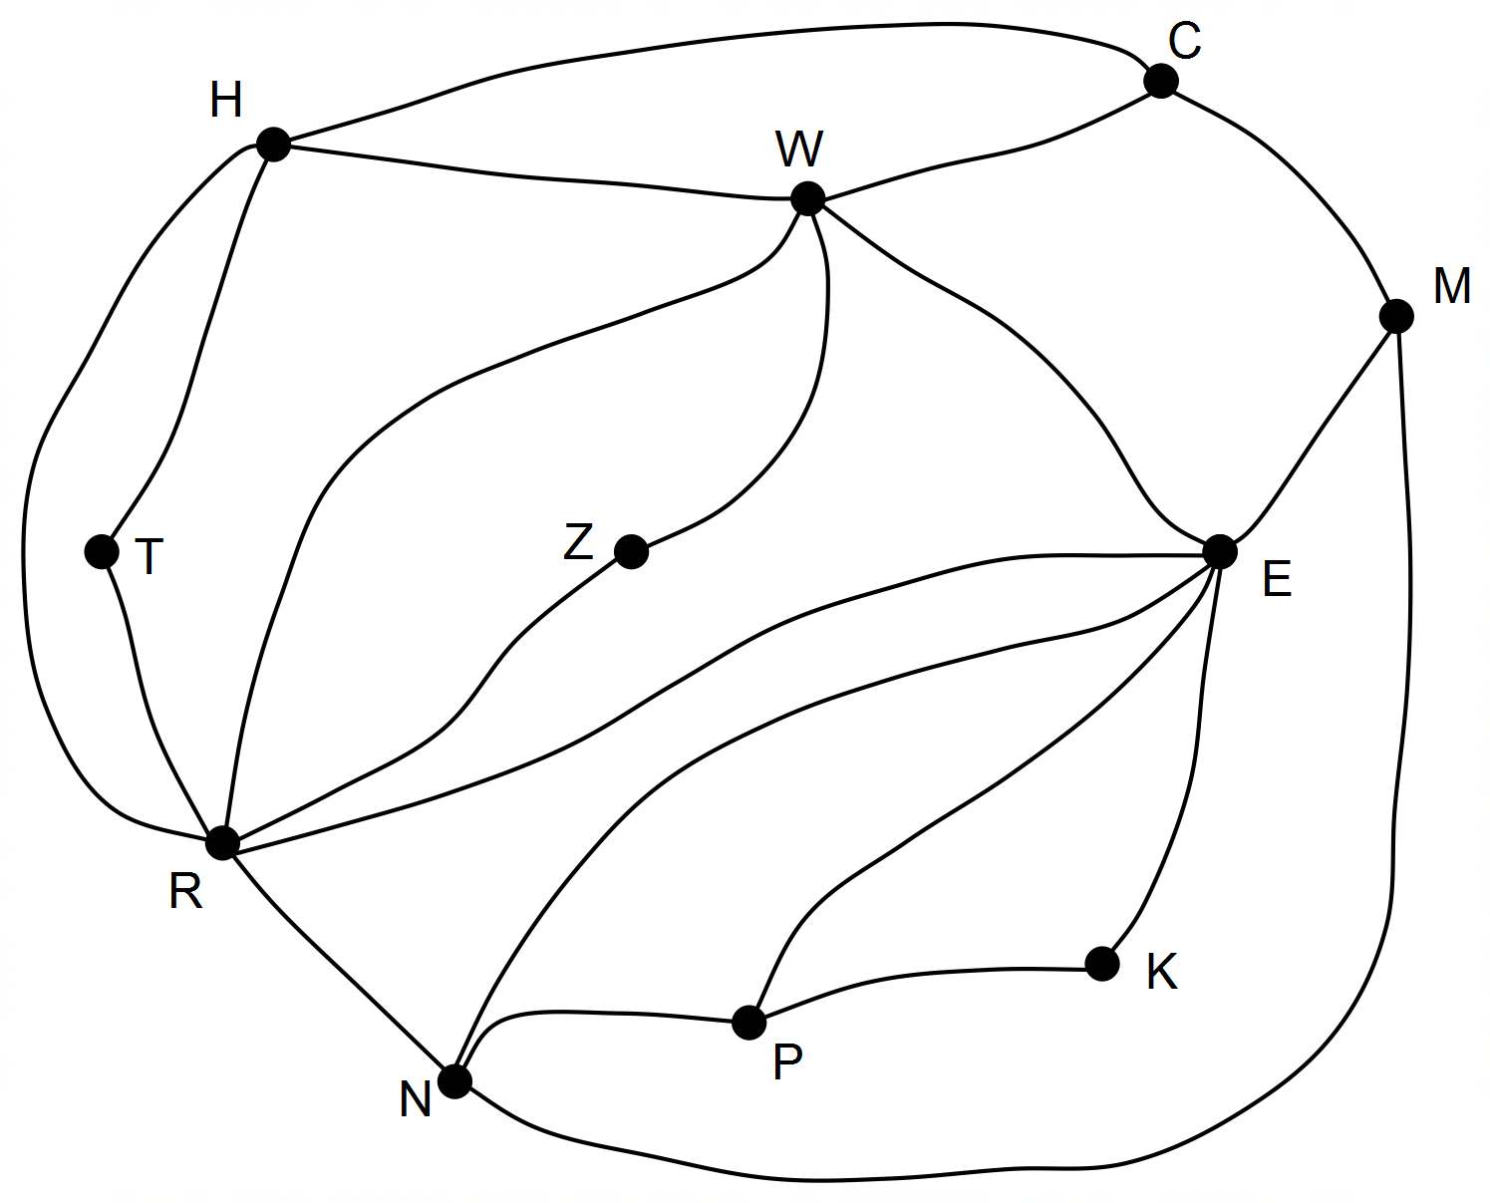

(a) What does each edge of the graph represent? (1 mark)

(b) Louise will start at station C, visit each station once only and finish at a different station.

She will **not** repeat any connections between stations.

Determine aroute for Louise to take. (3 marks)

(c) The graph is planar. Explain this description. (1 mark)

(d) Verify that Euler’s rule works for this graph. (2 marks)

(e) If Louise used RWH as the beginning of her route, she would not be able to follow the instructions to complete the route.

(i) Explain the problem with starting the route with RWH. (1 mark)

(ii) Determine another set of three consecutive stations that would not form a suitable route.

(1 mark)

**Question 3 (9 marks)**

Five teaching assistants are available to support the students in the pre-primary class.

The number of hours that each assistant is available on each day of the week is summarised in the matrix provided. In this matrix the five assistants are represented by A1, A2, A3, A4 and A5 and the days of the week are represented by M, T, W, Th, and F.

M T W Th F



|  |
| --- |
| A1 |
| A2 |
| A3 |
| A4 |
| A5 |

(a) Complete the weighted bipartite graph that represents the data in the matrix. (4 marks)

|  |  |  |
| --- | --- | --- |
| A1 |  | M |
| A2 |  | T |
| A3 |  | W |
| A4 |  | Th |
| A5 |  | F |

.

(b) The matrix below shows the number of hours that four different volunteers V1, V2, V3, V4 are available to help in the kindergarten class from Monday (M) to Thursday (Th). The teacher wants only one volunteer each day and would like to have as many hours of volunteering as possible. Use the Hungarian algorithm to determine which volunteers should come on which day and the maximum number of hours that can be achieved. (5 marks)

M T W Th



|  |
| --- |
| V1 |
| V2 |
| V3 |
| V4 |

**Question 4 (9 marks)**

Ben has established recursive rules for three different options to generate payment from an interest-bearing investment. Interest would be paid annually on the value of the investment and then an amount transferred to his working account for the future year’s expenses.

A: *V*n = 1.05 *V*n-1 – 1000 x 52

B: *X*n = 1.08 *X*n-1 – 1100 x 52

C: *Z*n = 1.10 *Z*n-1 – 1000 x 52

(a) Which rule shows the greatest amount allowed for future weekly expenses?

Justify your choice. (2 marks)

(b) Which rules, if any, use a forecasted interest rate of at least 10% per annum?

Justify your answer. (2 marks)

(c) Ben has an estimated $500 000 in his investment account. Estimate the value of the account after one year with rule A. (2 marks)

(d) Given the estimate of $500 000 in Ben’s account, for which of the three rules would the amount of the investment most likely be the highest after five years. Justify your decision with reference to the values used in the rules. (3 marks)

**Question 5 (11 marks)**

The graph shows the number of attempts to score and the number of successes in a national sporting competition.

(a) The scores for two players have been omitted. These scores are given below.

Player A: Coordinates are (36, 9)

Player B: 73 attempts and 36 successes.

Mark and label the scores for both players . (2 marks)

(b) Identify the explanatory variable. (1 mark)

(c) The equation of the least squares line that models these data is:

Number of success = 0.5 x Number of attempts + 2.3

(i) The vertical intercept is 2.3 but this cannot be a data point. Explain. (1 mark)

(ii) As the number of attempts increases by 10, what is the predicted increase in the number of successes? Justify your answer. (2 marks)

(d) The graph represents the most and least successful players for that year but only those with 28 or more attempts are shown. Would you expect the most successful players to be ABOVE or BELOW the line shown on the graph? Explain your choice of answer.

(2 marks)

(e) If the scores for the 10 best players were removed, would the correlation coefficient INCREASE or DECREASE? Explain. (2 marks)

(f) Which of these plots with the residual shown on the vertical axis, is most likely to be the residual plot for these data? (1 mark)

|  |  |  |
| --- | --- | --- |
| A | B. | C. |

**Question 6 (6 marks)**

The local council has decided to connect the sporting facilities in the area by developing cycle paths along existing roads. The graph below shows the sporting facilities at the nodes, the existing roads connecting these facilities and the distances (km) between facilities when travelling along these roads.

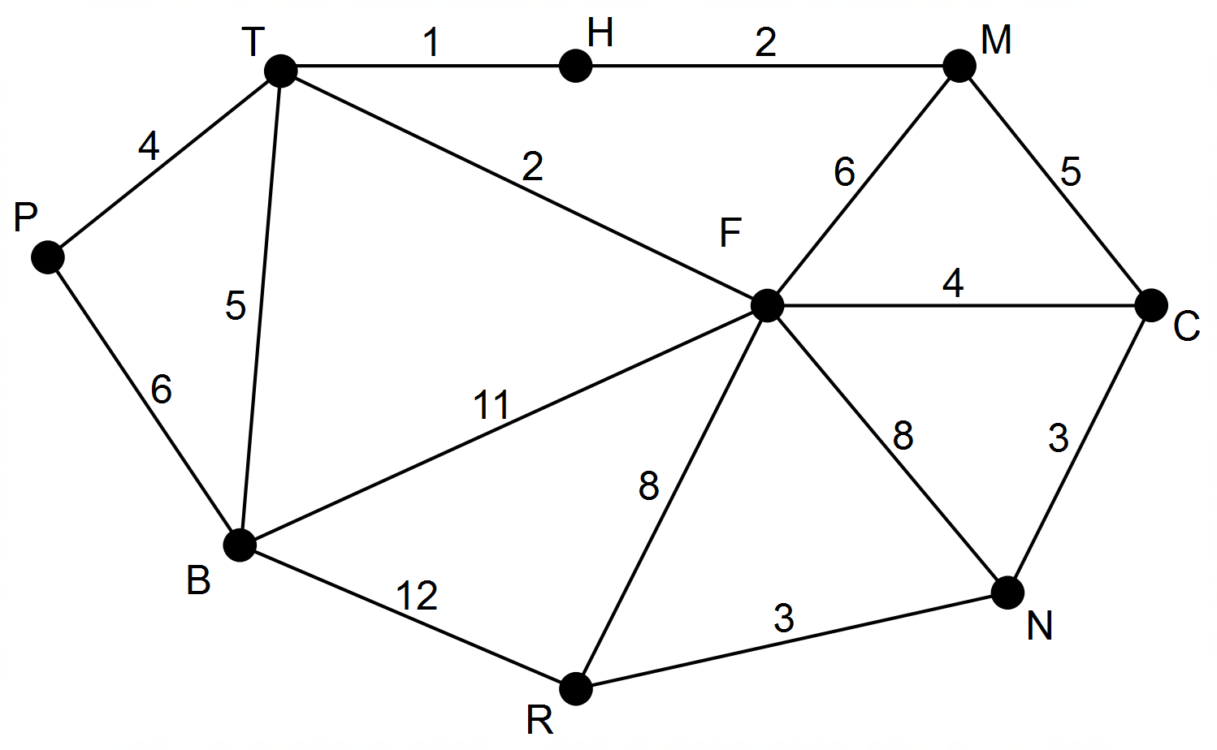

(a) Determine the length of minimum spanning tree for the development of the cycle paths and show this minimum spanning tree on the graph. (3 marks)

(b) Name the existing roads along which there would be no cycle paths according to the spanning tree identified in part (a). (1 mark)

(c) The council later discovered that the road connecting T and H and the road connecting R and N were not wide enough for a cycle path. What difference, if any, does this make to your answer to part (a). (2 marks)

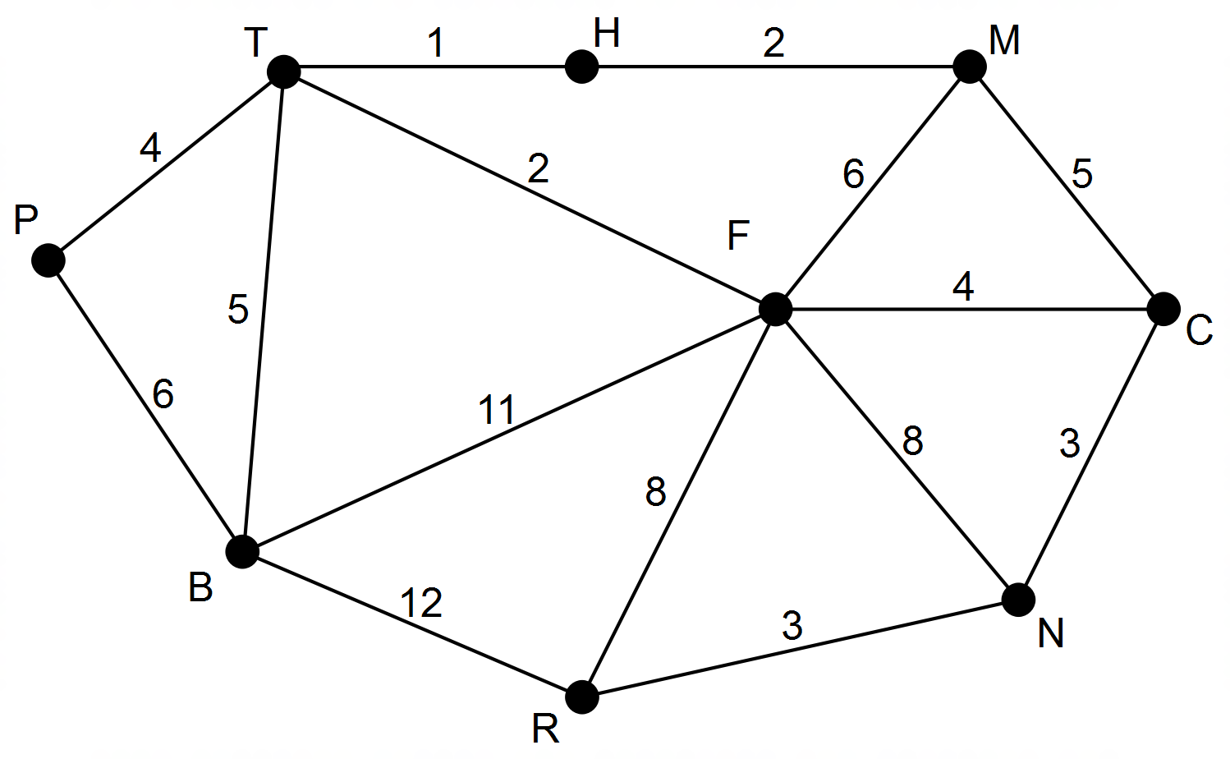

**End of Questions**

Additional working space

Question number: __________________

Data for Question 5 was obtained from The West Australian (July 2015)

© MAWA, 2017

This examination is Copyright but may be freely used within the school that purchases this licence.

* The items that are contained in this examination are to be used solely in the school for which they are purchased.
* They are not to be shared in any manner with a school which has not purchased their own licence.
* The items and the solutions/marking keys are to be kept confidentially and not copied or made available to anyone who is not a teacher at the school. Teachers may give feedback to students in the form of showing them how the work is marked but students are not to retain a copy of the paper or marking guide until the agreed release date stipulated in the purchasing agreement/licence.

*Published by The Mathematical Association of WA*

*12 Cobbler Place, MIRRABOOKA 6…*

**Acknowledgements**